**Question1:**

**Code:**

/*

Name: Abdullah Mehdi

Regstration No: SP21-BCS-OO2

Question 1: Social security numebr

*/

import java.util.Scanner;

public class ClassQ1{

public static void main(String[] args) {

Scanner input = new Scanner(System.in);

System.out.println("Enter your SSN");

String str = input.next();

String fHyphen = str.substring(3, 4);

String sHyphen = str.substring(6, 7);

if(str.length() == 11 && fHyphen.equals("-") && sHyphen.equals("-")){

System.out.println(str + " is a valid social security number");

}

else{

System.out.println(str + " is not a valid social security number");

}

}

}

**Output:**

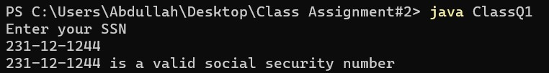

**Question2:**

**Code:**

/*

Name: Abdullah Mehdi

Regstration No: SP21-BCS-OO2

Question 2: CHECKING SUBSTRING

*/

import java.util.Scanner;

public class ClassQ2{

public static void main(String[] args) {

Scanner input = new Scanner(System.in);

System.out.println("Enter a string");

String str = input.next();

System.out.println("Enter another string");

String str2 = input.next();

char chr = 'a';

char chr2 = 'a';

for(int i = 0; i < str.length(); i++){

chr = str.charAt(i);

for(int j = 0; j < str2.length(); j++){

chr2 = str2.charAt(j);

}

}

if(chr2 <= chr){

System.out.println(str2 + " is a substring of " + str);

}

else{

System.out.println(str2 + " is not a substring of " + str);

}

}

}

**Output:**

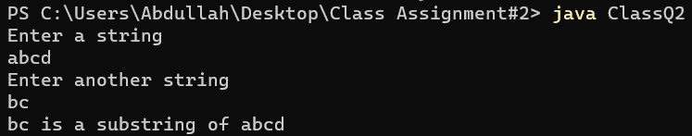

**Question3:**

**Code:**

/*

Name: Abdullah Mehdi

Regstration No: SP21-BCS-OO2

Question 3: Number Plate

*/

import java.util.*;

public class ClassQ3{

public static void main(String[] args) {

Random input = new Random();

for(int i = 0; i < 3; i++){

int str = input.nextInt(26) + 65;

System.out.print((char)str);

}

for(int j = 0; j < 4; j++){

int str2 = input.nextInt(10);

System.out.print(str2);

}

}

}

**Output:**

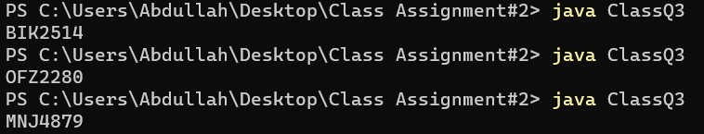

**Question4:**

**Code:**

/*

Name: Abdullah Mehdi

Regstration No: SP21-BCS-OO2

Question 4: Printing Leap years

*/

public class ClassQ4{

public static void main(String[] args) {

int i;

int j = 0;

int count = 0;

String s1 = "";

for(i = 101; i <= 2100; i++){

if(i % 4 == 0){

System.out.print(i + " ");

count++;

j++;

}

if(j == 10){

System.out.print(" \n");

j = 0;

}

}

System.out.println("The total number of leap years are: " + count);

}

}

**Output:**

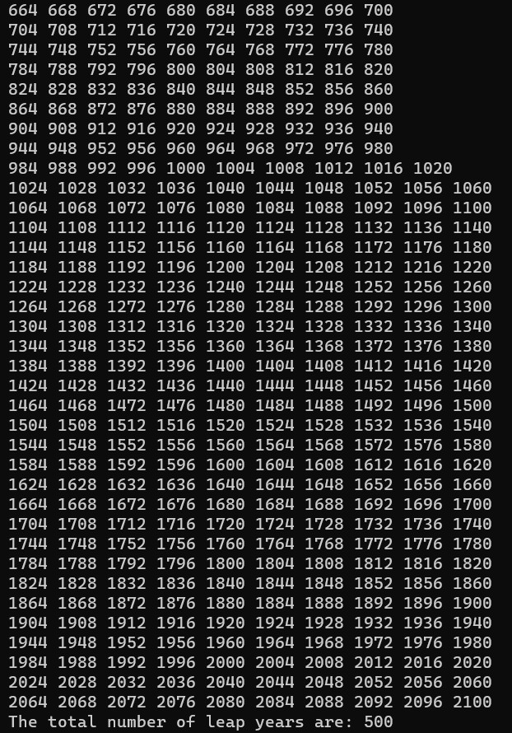

**Question5**

**Code:**

/*

Name: Abdullah Mehdi

Regstration No: SP21-BCS-OO2

Question 5: Binary

*/

import java.util.*;

public class ClassQ5{

public static void main(String[] args) {

Scanner input = new Scanner(System.in);

System.out.println("Enter a number");

int num = input.nextInt();

String str = "";

while (true){

int binary = num % 2;

num = num / 2;

str += binary;

if(num == 1){

str = str + num ;

break;

}

}

String s2 = "";

for (int i = str.length()-1; i >= 0; i--){

s2 += str.charAt(i);

}

System.out.println(s2);

}

}

**Output:**

